Design Pattern
- Creational Design Patterns
  - SingleTon
  - Factory
  - Builder
  - Prototype
- Structural Design Patterns
  - Adapter
  - Proxy
  - Facade
- Behavioral Design Patterns
  - Observer
  - Chain of Responsibility
  - Strategy
  - State Pattern
  - Visitor Pattern

Factory
3 type of factory pattern:
- Simple Factory
- Factory method pattern and
- Abstract factory Pattern

- It is a design pattern which is used to create objects without exposing the object creation logic to the clients.
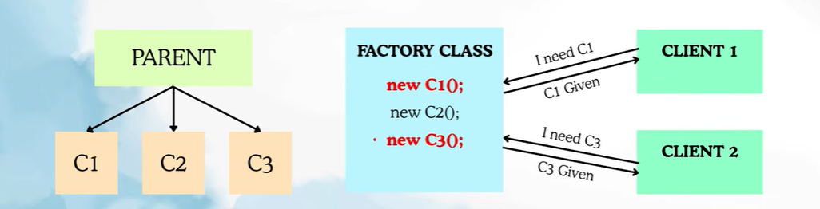
Simple factory
public interface Notification {
public void send();
}
public class EmailNotification implements Notification{
@Override
public void send() {
System.out.println("Email Notification");
}
}
public class SmsNotification implements Notification{
@Override
public void send() {
System.out.println("SMS Notification");
}
}
public class NotificationFactory {
public static Notification setNotification(String typeNotification) {
if(typeNotification.equals("EMAIL")){
return new EmailNotification();
}
else if(typeNotification.equals("SMS")){
return new SmsNotification();
}
throw new IllegalArgumentException("Invalid Type");
}
}
public class OrderService {
public void sendNotification() {
Notification notification = NotificationFactory.setNotification("EMAIL");
notification.send();
}
}
public static void main(String[] args) {
OrderService orderService = new OrderService();
orderService.sendNotification();
}

- Factory Method pattern: It defines an interface for creating objects, and allows subclasses to decide which concrete object to create.
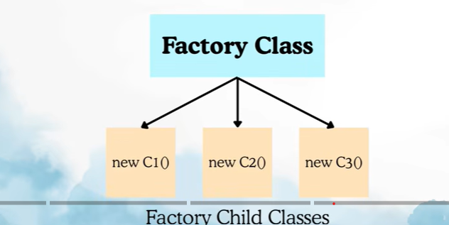
public interface NotificationFactory {
Notification createNotification();
}
public class EmailFactory implements NotificationFactory{
@Override
public Notification createNotification() {
return new EmailNotification();
}
}
public class DeliveryService {
public void sendNotification() {
NotificationFactory factory = new EmailFactory();
Notification notification = factory.createNotification();
notification.send();
}
}
public static void main(String[] args) {
OrderService orderService = new OrderService();
orderService.sendNotification();
}

- Abstract Factory: It is a design pattern which provides an interface for creating families of object without specifying their concrete classes.
